Query Manager – SQL Queries

<http://localhost:4502/bin/querybuilder.json?property=cq%3atemplate&property.value=%2fapps%2fr%2ftechdocs%2ftemplates%2farticlePage&type=cq%3aPageContent>

AEM query builder is a tool/framework developed by adobe for writing simple and efficient queries in AEM.

 In real world the performance of a website depends on its back end queries, which makes it really important to understand how query works in AEM and how to write efficient queries.

* What is Query Builder?
* [How to use Query Builder Debugger Tool in AEM.](http://www.aemcq5tutorials.com/tutorials/adobe-aem-cq5-tutorials/aem-query-builder/#query-builder-debugger-tool)
* [AEM Query Structure](http://www.aemcq5tutorials.com/tutorials/adobe-aem-cq5-tutorials/aem-query-builder/#aem-query-structure).
* [AEM Query Standard Predicates](http://www.aemcq5tutorials.com/tutorials/adobe-aem-cq5-tutorials/aem-query-builder/#aem-query-standard-predicates).
* [How to use Query Builder JAVA API.](http://www.aemcq5tutorials.com/tutorials/adobe-aem-cq5-tutorials/aem-query-builder/#query-builder-java-api)
* [Troubleshooting AEM Query](http://www.aemcq5tutorials.com/tutorials/adobe-aem-cq5-tutorials/aem-query-builder/#troubleshooting-aem-query)

**What is Query Builder?**

AEM Query Builder is a framework developed by adobe to build queries (JCR XPath underneath) for a query engine (OAK Query Engine) which are simple to compose. A query can be described as simple set of predicates in key value form.

**How AEM query builder works internally?**

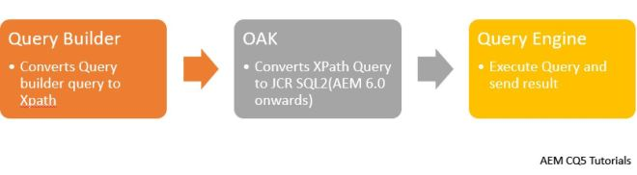

1. Query builder will convert the query builder query to Xpath.
2. Oak will convert the Xpath query to JCR SQL2(X-Path and JCR SQL are deprecated from AEM 6.0 as jackrabbit upgraded to OAK)
3. Query engine will execute the query and send the result back.

Note: AEM 6.3 onwards unindexed queries will give a warning/be denied.

#### ****How to use Query Builder Debugger Tool in AEM:-****

AEM comes with a Query Debugger tool using which you can execute search queries on the JCR (Java Content Repository).

***AEM Query Builder debugger URL:-***  [***http://localhost:4502/libs/cq/search/content/querydebug.html***](http://localhost:4502/libs/cq/search/content/querydebug.html)

##### **Debugging AEM Query Logs:-**

Debugging AEM query is very critical when you are looking for its performance or any error in AEM query. Follow below steps to enable AEM Query Debugger:-

* Navigate to <http://localhost:4502/system/console/slinglog> .
* Click on Add new logger (It might be useful to create a new log file for query, you can use any existing log file also.)
  + Enter Log file Name (query.log).
  + Set Log level to Debug or Trace.
  + TRACE will also show filtering per node (useful when writing custom filtering)
  + Avoid DEBUG or lower log level in production environment.
  + Add below 3 class files for debugging.

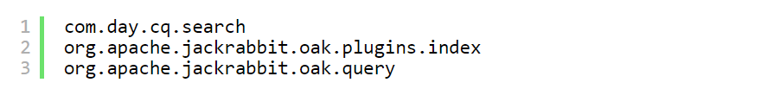

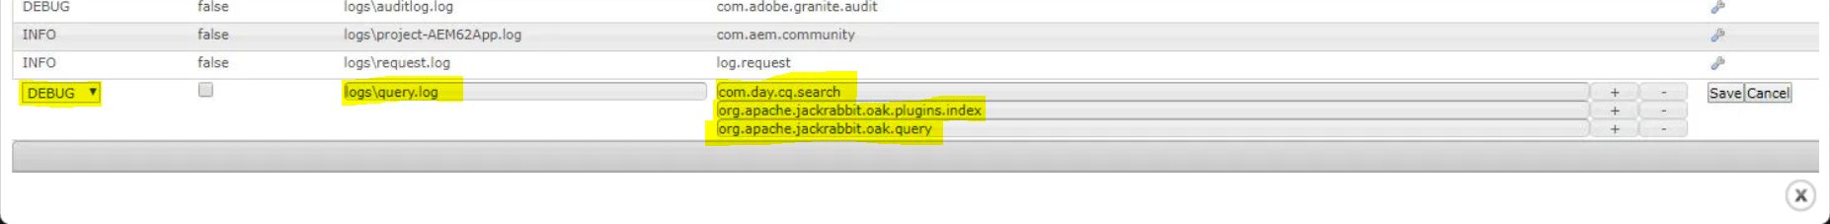

* Click on **save**.
* Go to Query builder console and run a simple query like:-
  + type=dam:Asset

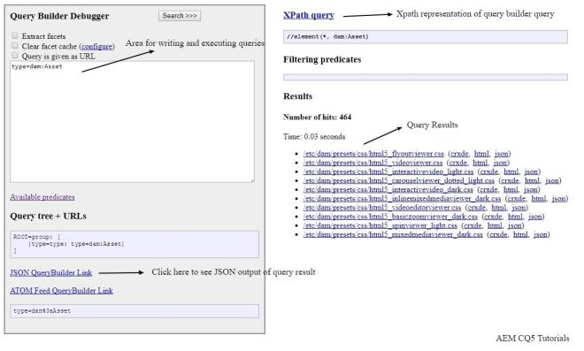

* Go to query.log file that we have created.
* You can see below logs specifying the query execution time, cost, index used and you can check how oak is converting Xpath queries to SQL2 internally.

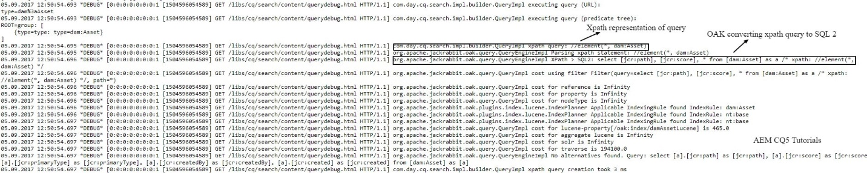

#### ****AEM Query Structure:-****